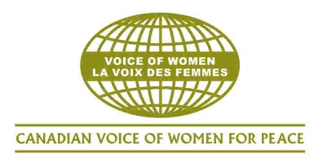 | Canadian Voice of Women for Peace (VOW)  60 Lowther Avenue, Toronto, ON M5R 1C7 | 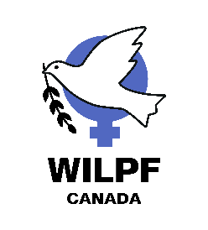 | Women’s International League for Peace & Freedom (WILPF) Canada  c/o PO Box 11466, Vancouver RPO  River District, BC V5S 0J3
February 10, 2026

The Right Honourable Mark Carney, P.C., M.P.  Office of the Prime Minister  80 Wellington Street  Ottawa, ON  K1A 0A2 | The Honourable Anita Anand, P.C., M.P.  Minister of Foreign Affairs  House of Commons  Ottawa, ON  K1A 0A6
Re: JOINT LETTER: Reduce the nuclear threat, prioritize disarmament, make the Arctic a Nuclear-Free Zone of Peace & Cooperation, and join the Treaty on the Prohibition of Nuclear Weapons

Dear Prime Minister Carney and Minister Anand,

The Bulletin of Atomic Scientists has recently moved the hands of the Doomsday clock to 85 seconds to midnight, which represents the closest humanity has ever been to global catastrophe. The Bulletin explained that “Hard-won global understandings are collapsing, accelerating a winner-takes-all great power competition and undermining the international cooperation critical to reducing the risks of nuclear war, climate change, the misuse of biotechnology, the potential threat of artificial intelligence, and other apocalyptic dangers.” As well, the New START Treaty for the control of nuclear weapons between the United States and Russia has regrettably expired.

We, the Canadian Voice of Women for Peace and the Women’s International League for Peace & Freedom Canada, are writing to you about our grave concerns on the growing threat of nuclear weapons and appealing to you to show more “middle power” leadership for disarmament, peace and multilateral cooperation to help move the clock back. As well, we denounce (ret.) General Eyre’s suggestion that Canada acquire nuclear weapons to assert our sovereignty and express our firm opposition. As women’s organizations, we bring to your attention that research shows that ionizing radiation related to nuclear weapons production and testing disproportionately harms women and children (see: Nuclear Weapons Issues are Women’s Issues by Emma Sandifer, Center for Arms Control and Non-Proliferation, March 31, 2025: https://armscontrolcenter.org/nuclear-weapons-issues-are-womens-issues/). We would like to see Canada take more action on disarmament and make the following recommendations.

First, Canada must fulfill its obligations under the Treaty on the Non-Proliferation of Nuclear Weapons (NPT). The 11th Review Conference of the Parties will take place at the United Nations in New York this April. We call on the federal government to send a strong delegation with civil society experts and take meaningful steps to implement Article 6 of the NPT to “pursue negotiations in good faith on effective measures relating to cessation of the nuclear arms race at an early date and to nuclear disarmament.”

Second, Canada’s procurement of F-35 fighter jets, which are designed to carry tactical nuclear weapons, is a violation of the NPT. The price tag of the fossil fuel-powered, nuclear capable F-35 fleet is $27 billion with a life-cycle cost of $74 billion. The federal government should not waste any Canadian tax dollars on warplanes, cancel the F-35 procurement, and instead invest in social welfare, climate action, peacebuilding, and diplomacy.

Third, Canada must withdraw from the “Coalition of the Willing” and stop sending weapons to Ukraine, which risk a nuclear escalation with Russia. The federal government should help broker a genuine peace that resolves the roots causes of the conflict and end this tragic war.

Fourth, the federal government must stop exporting arms to Israel, which is a nuclear-armed state committing a genocide against the Palestinian people and threatening Iran. Canada should support a Nuclear Weapons-Free Zone (NWFZ) in the Middle East.

Fifth, Ottawa should bring together Arctic states to make the region a NWFZ for peace and cooperation. The federal government should not militarize the Arctic, a vulnerable oceanic ecosystem that regulates the climate, into a new battlefield for NATO and NORAD. The Inuit Circumpolar Council has proposed the Arctic as a zone of peace and cooperation for many years.

Sixth, the federal government should consult more regularly with Canadian civil society and provide funding for research and activities on peace, peace education, peacebuilding and disarmament. Canada has not held a foreign policy review with the public in twenty-two years.

Seventh, Canada must withdraw from the North Atlantic Treaty Organization (NATO), the U.S.-led nuclear-armed alliance, to assert independence over our foreign policy. Canada should work collaborating with the 163 countries that are not in NATO through the UN system. Canada should instead join the Treaty on the Prohibition of Nuclear Weapons (TPNW), which is supported by the majority of the Canadian public, has been ratified by 74 countries, and has marked its fifth anniversary of coming into force.

The Executive Director of the International Campaign to Abolish Nuclear Weapons (ICAN), Melissa Parke, explained that “The Doomsday Clock is not a prediction, it’s a warning. Nuclear weapons, wars from Ukraine to Gaza, the climate crisis and runaway technologies are all part of the problem – but they are all created by humanity. That means we can also change course. The Treaty on the Prohibition of Nuclear Weapons (TPNW) is a clear path to turn back the hands of the clock.” We urge Canada to join the TPNW and send a delegation to the next review conference.

Finally, we appreciate your attention to our concerns. We are also requesting an online meeting with Minister Anand to discuss our concerns related to Canada’s position on nuclear disarmament and other foreign policy issues. We can set up a zoom call with you at your convenience. We can be reached by email: info@vowpeace.org or by phone: 416-603-7915. We want Canada to advance disarmament and peace in the world.

Thank you for your attention to our concerns.

Sincerely,
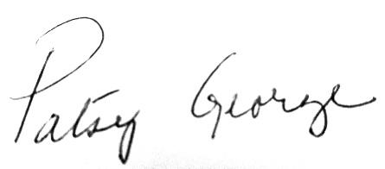 | 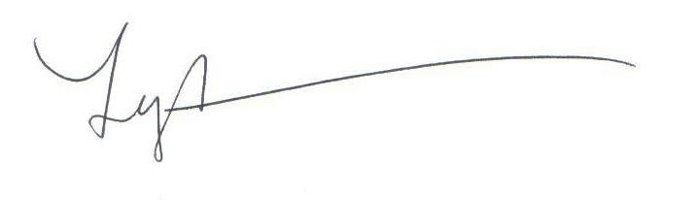
____________________________  Co-chair Patsy George  On behalf of co-chair Ellen Woodsworth and board the Women’s International League for Peace & Freedom (WILPF) Canada | ___________________________  Co-chair Lyn Adamson  On behalf of co-chair Hannah Hadikin and the board the Canadian Voice of Women for Peace (VOW)

Encl.
2026 Doomsday Clock Statement
cc:
Hon. Pierre Poilievre, Leader of the Conservative Party of Canada
Hon. Yves-François Blanchet, Leader of the Bloc Québécois
Hon. Don Davis, Interim Leader of the New Democratic Party
Hon. Elizabeth May, Leader of the Green Party of Canada

Canadian Voice of Women for Peace (VOW) is the largest national feminist peace organization with members and chapters across the country. VOW was established in 1960 and is a non-partisan, non-governmental organization comprised of a network of diverse women. VOW’s main office is in Toronto. VOW runs many campaigns related to women, peace, disarmament and anti-militarism. VOW has consultative status at the United Nations Economic and Social Council (ECOSOC) and every year brings a delegation of Canadian women to the UN Commission on the Status of Women conference. For over 60 years, VOW has tirelessly advocated for a world without war. VOW stands for a feminist peace based on nonviolence, disarmament, diplomacy and common security with gender equality.
Web site: http://vowpeace.org
Women’s International League for Peace & Freedom (WILPF) Canada is a membership-led organization committed to a feminist peace, social justice, and gender equality. We are a non-partisan, non-governmental organization members across the country. We are the national section of WILPF International, which is the world's longest standing women peace organization founded in 1915, with 32 Sections and 13 Groups across Africa, the Americas, Asia, Europe, and the Middle East. Two of our leaders, Jane Addams and Emily Greene Balch, won the Nobel Peace Prize. WILPF International is headquartered in Geneva, Switzerland and has a disarmament program called Reaching Critical Will in New York. Our Peace Women program monitors the United Nations’ Women, Peace & Security agenda and we have an international Environment Working Group.
Web site: wilpfcanada.ca
VOW and WILPF-Canada are also members of the Global Women for Peace United Against NATO: https://womenagainstnato.org/ and the Canada-Wide Peace and Justice Network: https://peaceandjusticenetwork.ca/

